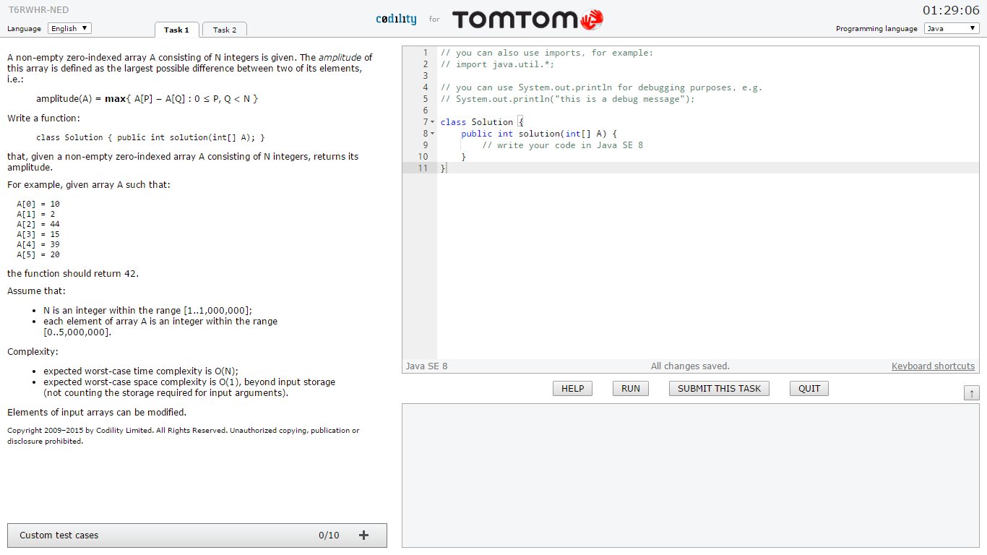

|  |
| --- |
| // you can also use imports, for example:  // import java.util.*;  // you can use System.out.println for debugging purposes, e.g.  // System.out.println("this is a debug message");  class Solution {  public int solution(int[] A) {  // write your code in Java SE 8  }  } |

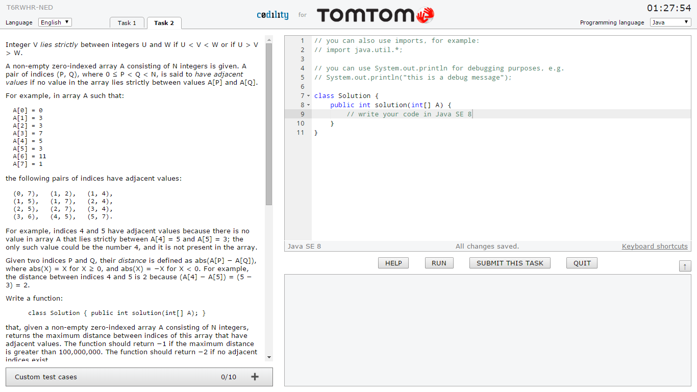

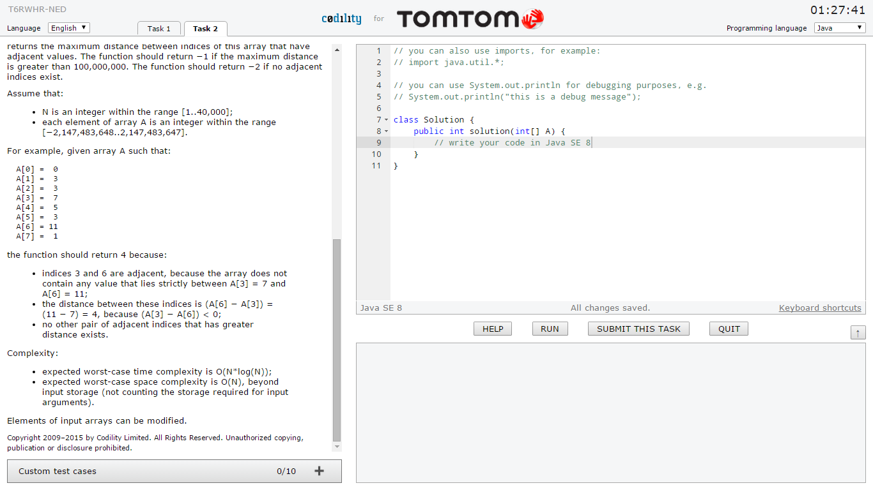

|  |
| --- |
| // you can also use imports, for example:  // import java.util.*;  // you can use System.out.println for debugging purposes, e.g.  // System.out.println("this is a debug message");  class Solution {  public int solution(int[] A) {  // write your code in Java SE 8  }  } |